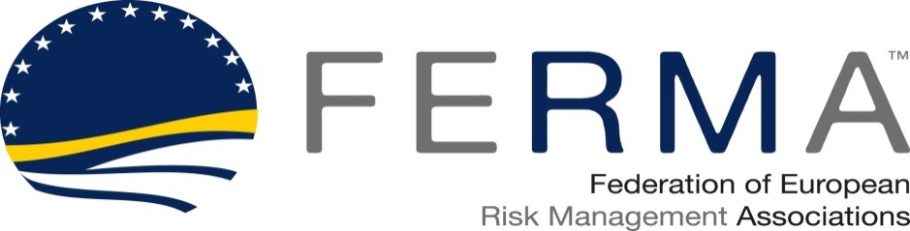

07 April 2016
FERMA European Risk and Insurance Survey 2016 starts Friday in 21 European countries
On Friday 8 April, the Federation of European Risk Management Associations (FERMA) will launch its 2016 European Risk and Insurance Survey in cooperation with its member associations in 21 countries. The survey is the widest expression of the views of risk and insurance managers across Europe. It has taken place every other year since 2002 and is now in its eighth edition.
The online questionnaire is available in seven languages: English, French, German, Italian, Polish Spanish and Turkish. As before, an independent research company will collect the responses and compile the findings. The results will be published as the FERMA European Risk and Insurance Report at the FERMA Seminar on 3-4 October in Malta. The report will then form the basis of further research by FERMA and its member associations, as well as providing benchmarks for individual risk managers to use in their own work.
FERMA president Jo Willaert, said: “The world is changing rapidly and is certainly different since the last survey in 2014. Gathering up-to-date data and evidence will provide valuable information for risk and insurance managers in their companies and will contribute to the visibility of the profession. The FERMA European Risk and Insurance Report is also a source of strategic information for FERMA to position risk management in debates at EU and international levels.”

FERMA Vice-President Cristina Martinez, who is the Survey project chairman said: “The survey is conducted by risk managers for risk managers. It is now in its eighth edition. This means we can see how we have developed as a profession since the first edition in 2002 and where we are today. There is no other source of information like this.”
The Survey questions have been compiled with support from the member associations and five commercial partners: AIG, Chubb, EY, Marsh and XL Catlin. There are three sections covering: the respondent’s organisation, the role of the risk manager and the risk management profession; European insights on risk management and risk financing, including insurance and captives.

Press contacts
Lee Coppack, FERMA media coordinator
lee@coppack.co.uk
+44 (0) 208 318 0330/+44 (0) 7843 089904

About FERMA
The Federation of European Risk Management Associations (FERMA) brings together 23 national risk management associations in 21 European countries. FERMA has more than 4700 individual members representing a wide range of business sectors from major industrial and commercial companies to financial institutions and local government bodies. These members play a crucial role for their organisations with respect to the management and treatment of complex risks and insurance issues.

Member associations are from the following countries: Belgium (BELRIM), Bulgaria (BRIMA), Czech Republic (ASPAR CZ), Denmark (DARIM), Finland (FinnRiMa), France (AMRAE), Germany (DVS/BfV), Italy (ANRA), Luxembourg (ALRiM), Malta (MARM), Netherlands (NARIM), Norway (NORIMA), Poland (POLRISK), Portugal (APOGERIS), Russia (RusRisk), Slovenia (Sl.RISK), Spain (AGERS and IGREA), Sweden (SWERMA), Switzerland (SIRM), Turkey (ERMA) and United Kingdom (Airmic).

